**Human-Computer Interaction**

**STUDENT REGISTRATION SYSTEM**

**EVALUATION DOCUMENT**

**Members:**

Amna Mubarak 20k-1695

Ehtesham Zafar 20k-1655

Hassan Ali 20k-1052

**Q1) Explain Fluidity in your project.**

**Ans**) We developed our system to stay in the flow for fluidity. Where the flow incorporates all perfectly balanced activities and skills, resulting in high focus, involvement, and satisfying outcome.

While visual aspects are important for fluid interaction, it is the interactive aspects that are central for effective visualization interaction design.

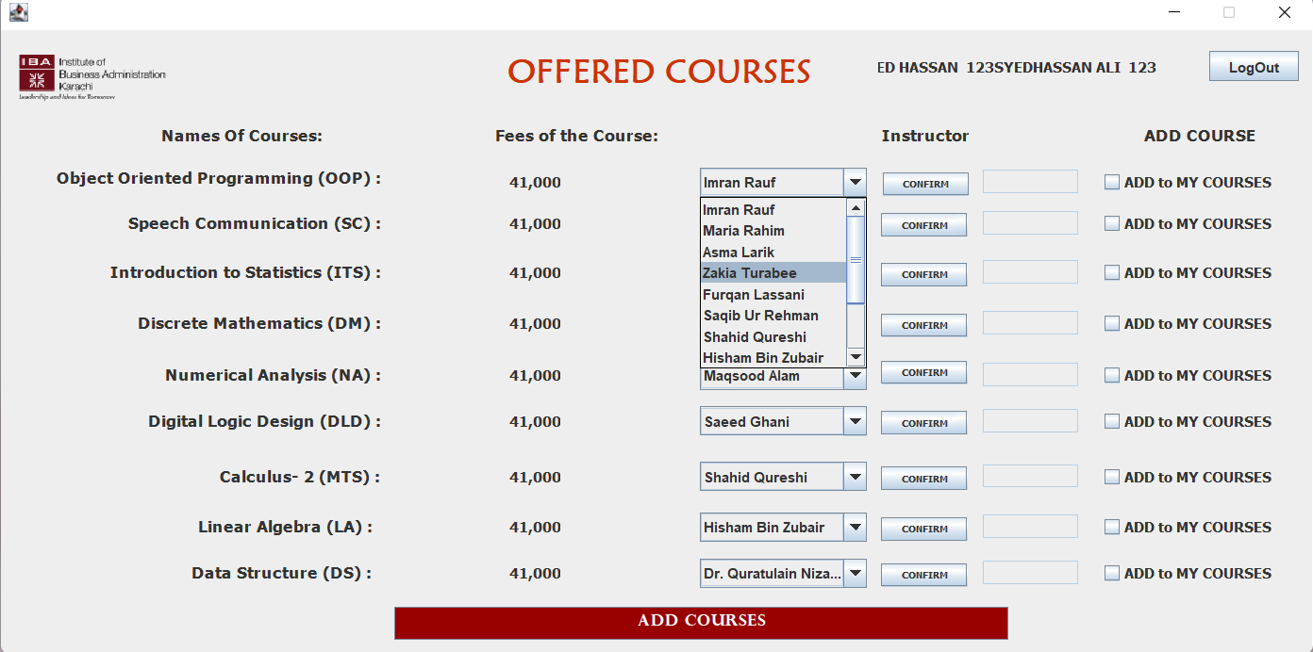

The above task of choosing the course instructor requires a higher degree of focus on a limited field of area. The user will also get prompt feedback as soon as he has selected the desired instructor. Lastly, it does not require much hard work so it will balance the user skills for this action.

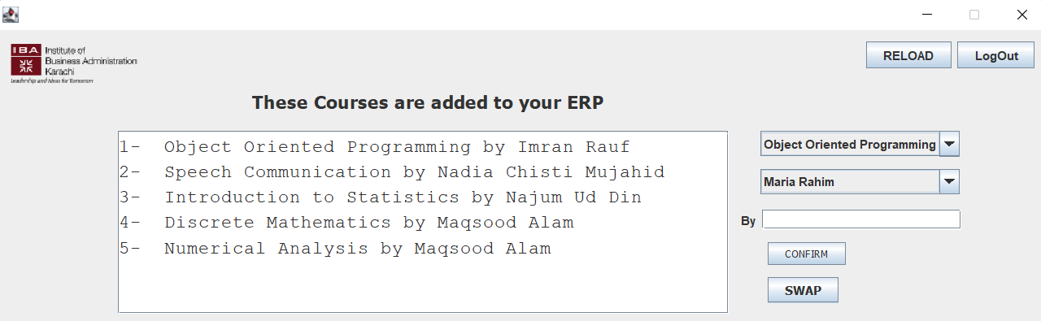

We have also tried to minimize the gulf of actions to avoid the difference between the system’s state and the user’s perception of the state by displaying the selected courses in the white dialogue box for maximizing clarity and expressiveness. This flow of transformation will provide users to achieve the next task with ease.

**Q2) Explain Signifiers in your project.**

**Ans)** Signifiers are characteristics of an item that a designer employs to signify the thing's potential and intended affordances.

Our project has these tick boxes that signify that the user has selected or turned on that particular object. This tick box signifies the affordance of this feature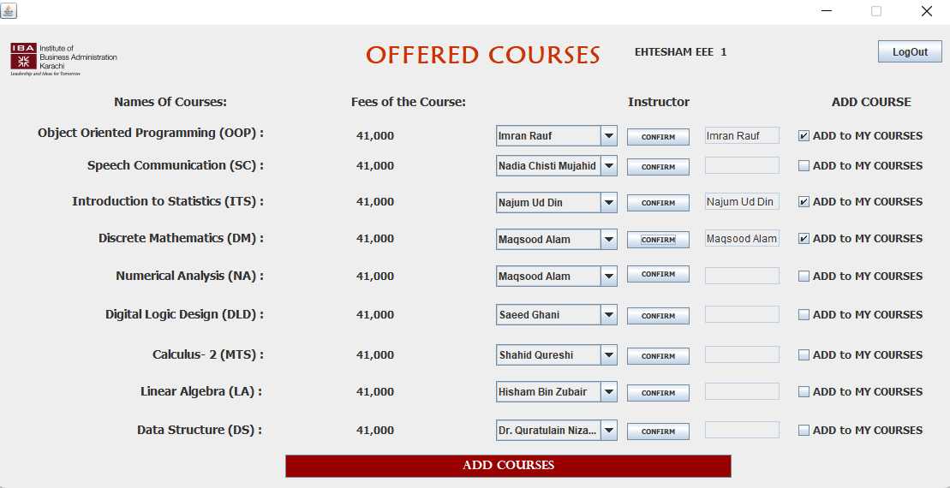

**Q3) How to reduce the formality gap in your project.**

**Ans)** Because of the formality gap, validation will always rely on subjective sources of verification to some level. We may boost our faith by displaying our software to the specialists to validate certain tasks. Because these specialists are unlikely to have any design experience, they may be unfamiliar with the design notations employed. As a result, it's critical that the design notations utilized close the formality gap, clarifying the assertions that the expert can then verify.

To reduce the formality gap, our software is designed in such a manner that the user would not require a lot of domain knowledge to interact with it, rather, our software is so interactive in a way that it has been made into an inductive interface that will help him complete the tasks itself.

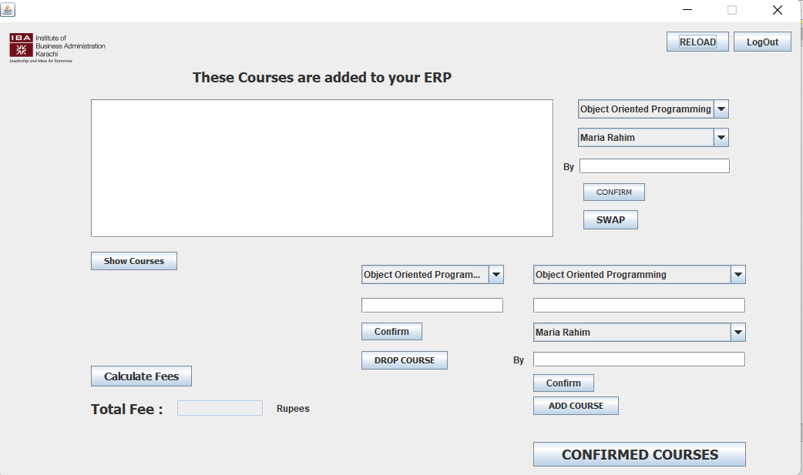

Here in this screen, there are multiple things that we did to reduce the formality gap.

1. At any point if the user requires to log out of the system, we have placed the logout button on every screen.
2. If the user does not feel confident that the courses which he/she has selected for themselves are allotted to them, they can click on show courses to view their selected courses.
3. The users do not have to take out the calculator to calculate the fees. They can just simply click here and the system would calculate the fees for them.

**Q4) Where is the internal locus of control implemented in your project.**

**Ans)** When the control is taken from the user by the system to give the user some warning or some remainder is known as internal locus of control.

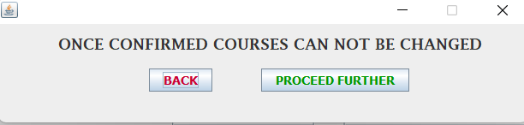

When the users click on the confirm courses option, they are given this warning box which tells the users that once they proceed further they cannot change or remove any course that they have selected.

**Q5) Where is Synthesizability implemented in your project.**

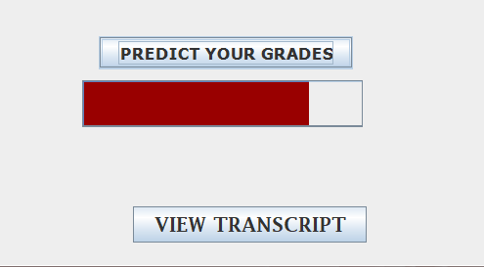**Ans)** It refers to eventual vs immediate honesty. Here we have assessed the past actions of the user and presented them to the current state, to make the operations visible.

After we have clicked the predicted grades, the green bar starts to proceed further to show that the task is executing. This execution is based on immediate honesty because the user is getting to know what’s happening with the past actions. Eventually, after this bar has reached its end the user can view the transcript. That will make sure that the user has made it to the eventual honesty part.